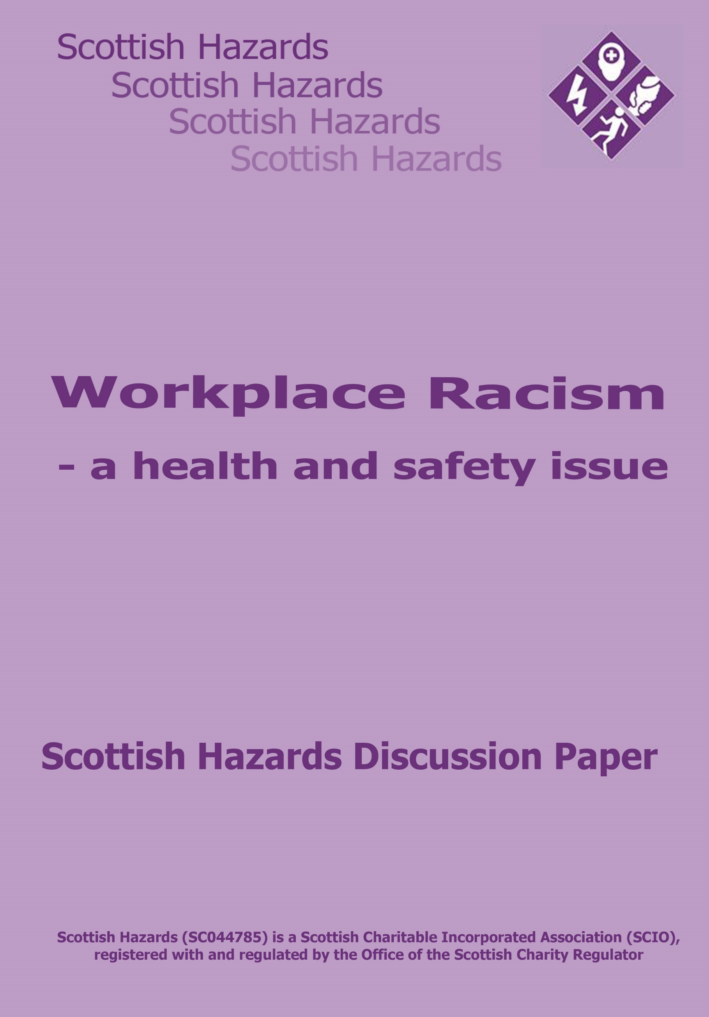

Introduction
Racism in the workplace goes beyond individuals being discriminated against because of ethnicity into areas largely ignored by employers, public policy makers and enforcement bodies; the impact that unacceptable workplace racism has on the health, safety and well-being of those subject to racist behaviour.
Employers have a duty of care to ensure the health, safety and welfare of its entire workforce but the experience of BME workers suggests, when it comes to workplace racism in all its manifestations - including bullying, victimisation, discrimination, physical violence, verbal abuse, being subject to racist comments and jokes - that employers and the legislation are letting BME workers down badly.
In 2016 the TUC commissioned ICM to carry out a poll of over 1000 BME workers across the United Kingdom and published the findings in 2017.
Is Racism Real showed 37% of BME workers reported having been bullied, abused or experienced racial discrimination at work including discrimination (19%), experienced verbal abuse, bullying or harassment (15%) or suffered assault or physical violence (4%).
The report identified managers as being the main perpetrators of assault, physical violence, bullying and harassment with racist opinions remarks and jokes mainly being directed at them by colleagues.
Sadly, the problem appears to be much worse for BME women with 57% of those polled reporting the bullying and harassment to such an extent it affected their mental health, 41% wanted to leave their job but could not afford to and 37% had left a job because of racist behaviour.
The report provides far more information on the extent of the problem than it is possible to cover here but it also provides opportunities for Scottish Hazards to work with the STUC and its affiliates to use the Fair Work agenda to tackle the adverse health and wellbeing impact workplace racism has on workers.

Fair Work and Workplace Racism
The Scottish Government is committed to having an economy with Fair Work as its foundation by 2025, a commendable though challenging ambition outlined in the work of the Fair Work Convention and the Fair Work Framework published in 2017.
Scottish Hazards strongly believes workplace health, safety, equality and workplace wellbeing runs right through the 5 dimensions of Fair Work; effective voice, opportunity, security, fulfilment and respect.
Looking at each one we can start to think about what needs to be done to tackle workplace racism and its health and safety impacts;
Effective Voice – Worldwide research shows that trade unionised workplaces are safer and healthier workplaces, in the United Kingdom this is demonstrated in the TUC publication “The Union Effect- how unions make a difference to health and safety”. This paper highlights how an effective safety voice drives health and safety performance. We need to ensure that workplace and trade union health and safety structures reflect the diversity of the workforce and membership and develop closer links between trade union health and safety reps and equality reps on occupational health issues arising from workplace racism.
The health and safety impacts of workplace racism can best be addressed by giving BME workers a louder and more effective voice, this could include ensuring health and safety issues related to racist behaviour are better understood by trade union health and safety reps and solutions negotiated as part of the collective bargaining agenda at workplace health and safety committees. Recruiting more health and safety reps and developing organising campaigns around workplace racism and health and safety should be considered, alongside the considerable opportunities to tackle workplace racism arising from the wider Fair Work Agenda.
Opportunity – the potential for workplace racism to have a wide range of adverse occupational health impacts and evidence of specific groups of BME workers being at higher risk of disease such as diabetes or poor mental health require to be addressed if equality of opportunity is to become a reality. Mapping the workforce and the workplace for both health and safety and diversity could provide valuable evidence to make real changes in this dimension. It has also become too easy for employers to dismiss workers on the grounds of capability, given increased health inequalities faced by BME workers this attitude needs to change and we should adopt the whole life approach to supporting people in work advocated by the Fair Work Convention ensuring the ability of BME workers is recognised rather than capability. The life stage approach should not only adapt work to ageing but should include supporting those with long term conditions to remain in work, particularly where the work environment has caused or contributed to the illness.
Security – many BME workers are exposed to precarious employment and according to another TUC report “Living on the Margins, Black workers and casualisation” BME workers have been disproportionately affected by the growth of part time, low paid and insecure employment in all its forms. This increases the chances of these workers suffering health inequalities associated with insecure employment such as increased risk of work-related injury or ill health and, when taken with exposure to workplace racism, it is evident we must address employment insecurity faced by BME workers if we are to ensure fairer, safer, healthier and more secure employment.
Fulfilment – From the results of the TUC poll a substantial proportion of those surveyed were obviously not in fulfilling work. Nearly 60% reported their mental health had been damaged by racism at work, while smaller - yet substantial - numbers stated unfavourable treatment based on their race had forced them to leave work to protect their health or, perhaps even more concerning, they wanted to leave their job but could not afford to, obviously having to risk their health to protect their livelihood. BME workers are expected to deliver the same performance as others but do not enjoy the same access to career progression. Employers should have clear and transparent criteria on career progression, personal development and training opportunities where every worker who fulfils the criteria will be considered for promotion on merit regardless of race. However, that alone will not provide fulfilling work for BME workers, that will only be provided when workplace racism is tackled to allow equality of access to all the components that define fulfilling work.
Respect - The TUC evidence also suggests to Scottish Hazards that many BME workers do not feel respected by management or colleagues. As the Fair Work frameworks alludes to, at its most basic level respect involves ensuring the health, safety and wellbeing of others. Leaving aside the legal obligations employers must ensure the health and safety of all their workers, Scottish Hazards believes a positive organisational health and safety culture, where individual wellbeing is acknowledged as are the organisational failings that act as a barrier to developing respectful workplaces could be delivered by challenging the workplace and health impacts of racism at work.

Conclusion
Everyone has a right to return home at the end of their working day or shift, not having been harmed or made ill by work. For BME workers they face significant challenges in exercising this right due to the behaviour of management and colleagues and the racist abuse directed at them.
Scottish Hazards believes both the issue of racism in the workplace and the adverse health impacts require to be addressed if BME workers are genuinely to enjoy equality of opportunity and healthier working lives that fair work and fair workplaces could deliver.
It is important the debate on how this is achieved happens now, and we would like the opportunity to work with the STUC and its affiliated unions to start the discussion on how we can change working lives for BME workers and ensure they have access to fair work, free from racism.
Scottish Hazards would like to work with the STUC Black Workers’ Committee to develop Fair Work for BME Workers. The Committee has a strong record of promoting equality and diversity while tackling inequality and Scottish Hazards can add our occupational health and safety expertise.
Our initial thoughts on some areas this work may consider are
- How can more BME workers be encouraged to become health and safety reps?
- Is there opportunity for BME health and safety specialists to support and mentor colleagues on BME specific health and safety issues?
- Could joint working between trade union equality reps and health and safety colleagues provide opportunities to mainstream BME health and safety issues into the wider equality and diversity agenda?
- What support is required to equip stewards, health and safety and equality reps to deal with long-term conditions more prevalent in the BME community and help them maintain functional capacity throughout their working lives? (this would benefit non-BME workers as well)
- Are workplace policies fit for purpose to protect BME workers from racism in the workplace, if so why are so many workers reporting extremely serious levels of mental ill health associated with workplace racism?
- Can we use public body supply chains to drive change in workplaces cultures where racism is embedded?
- How can we measure if BME workers are able to access training, skills and personal development and the impact that has on career progression and workplace health and wellbeing?
For further information contact Ian Tasker, ian@scottishhazards.org
Scottish Hazards
October 2018

https://www.tuc.org.uk/research-analysis/reports/racism-real
http://www.fairworkconvention.scot/framework/FairWorkConventionFrameworkFull.pdf
https://www.tuc.org.uk/sites/default/files/Union%20effect%202015%20%28pdf%29_0.pdf
https://www.tuc.org.uk/sites/default/files/LivingontheMargins.pdf

